Before you start cracking passwords, let’s do a guessing game, except it’s really easy. Sometimes people just use horrible passwords. Like, the password is so bad that it might show up in a meme as an example of a bad password, like the one below. 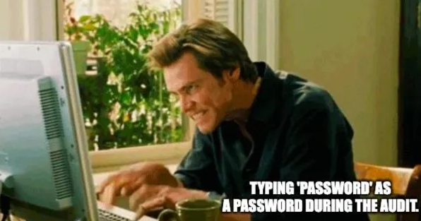
That might happen if someone forgets to change the default login on their machine or something. You won’t even have to crack that one. Go ahead and use the terrible, horrible, no good very bad password I hinted at here in order to open the zip file and go to the first real level.

